EXPERIMENT 4

Aim
Simulation of Routing Information Protocol (RIP)

Prerequisite
Nil

Outcome
To impart knowledge of Computer Networking Technology

Theory
RIP, or Routing Information Protocol, is one of the oldest and simplest routing protocols used in computer networks. It falls under the category of distance-vector routing protocols and is primarily used in small to medium-sized networks. Here's an explanation of RIP:
- Distance-Vector Protocol:
- RIP operates as a distance-vector protocol, which means it determines the best path to a destination based on the number of hops (routers) it takes to reach that destination. Each router maintains a routing table that contains information about the number of hops to various network destinations.
- RIP Versions:
- There are two main versions of RIP: RIP-1 and RIP-2.
- RIP-1: The original RIP version, defined in RFC 1058, supports classful routing and uses hop count as its metric.
- RIP-2: An improved version of RIP, defined in RFC 1723, supports classless routing (CIDR), VLSM (Variable Length Subnet Masking), and includes support for route authentication and multicast routing.
- Metric:
- RIP uses hop count as its metric to determine the best path to a destination. It assumes that the shortest path is the one with the fewest hops, which may not always be the most efficient route in terms of bandwidth or latency.
- Periodic Updates:
- RIP routers periodically broadcast their entire routing table to neighbouring routers. By default, RIP sends updates every 30 seconds.
- These updates contain information about reachable networks and their associated hop counts.

- Split Horizon and Route Poisoning:
- To prevent routing loops, RIP employs mechanisms like "split horizon" and "route poisoning."
- Split Horizon: Routers don't advertise routes back to the neighbour from which they learned them, reducing the risk of loops.
- Route Poisoning: When a router detects a route has failed, it advertises the failed route to its neighbours with an infinite metric (usually 16 hops). This informs other routers that the route is no longer valid.
- Convergence Time:
- One limitation of RIP is its relatively slow convergence time. When a network change occurs, it takes time for RIP routers to recognize the change, update their routing tables, and propagate the changes throughout the network.
- Loop Prevention:
- RIP uses a maximum hop count of 15 to prevent routing loops. Routes with a hop count of 16 or higher are considered unreachable.
- Authentication (in RIP-2):
- RIP-2 introduces the option for route authentication, which helps secure routing information exchanges between routers.
- RIP Limitations:
- RIP has several limitations, including its limited support for large networks, slow convergence, and its reliance on hop count as the sole metric, which may not always reflect the best path in terms of performance.
- Common Use Cases:
- RIP is typically used in small to medium-sized networks, such as home networks or small office setups, where simplicity is more important than advanced routing features.
In summary, RIP is a basic routing protocol that uses hop count as a metric to determine the best paths in a network. While it's simple to configure and suitable for smaller networks, it has limitations in terms of scalability and convergence speed, making it less suitable for large, complex networks. RIP-2, with its additional features, is an improvement over the original RIP protocol.
Procedure
- Physical Setup:
Set up the routers in a network topology. Connect them using Ethernet cables.
- Access Routers:
Use a computer with terminal software to access the command-line interface (CLI) of each router. You may need a console cable or access through SSH.

- Configure RIP:
Enter the CLI of each router.
Enter global configuration mode by typing: enable or configure terminal.
Configure RIP on each router using the following commands:
router rip
version 2
network <network-address>
- View Routing Table:
Use the following command to view the routing table:
show ip route
- Introduce Network Changes:
Disconnect and reconnect Ethernet cables to simulate network changes.
- Monitor RIP Updates:
Continuously monitor the routing tables on both routers using the show ip route command as RIP updates the routing information.
Output
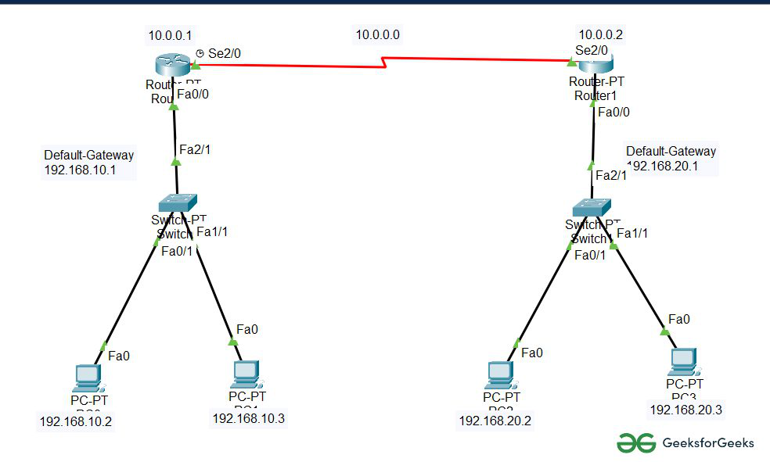
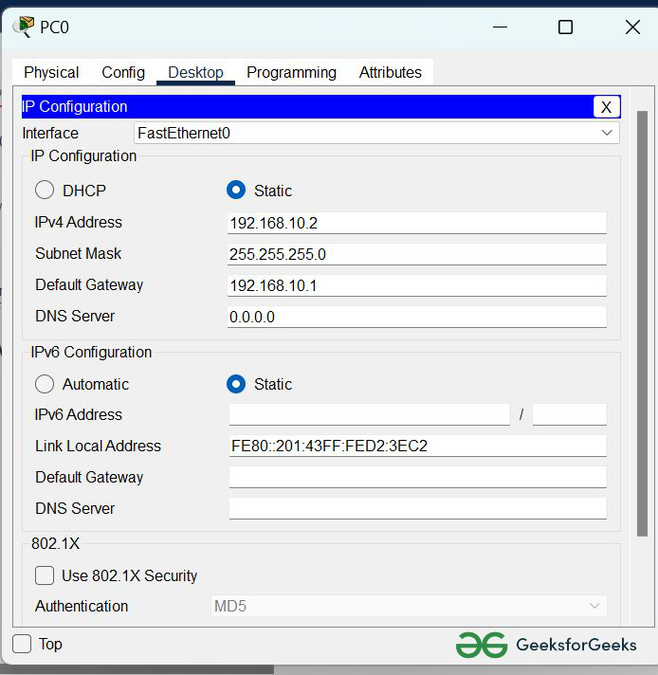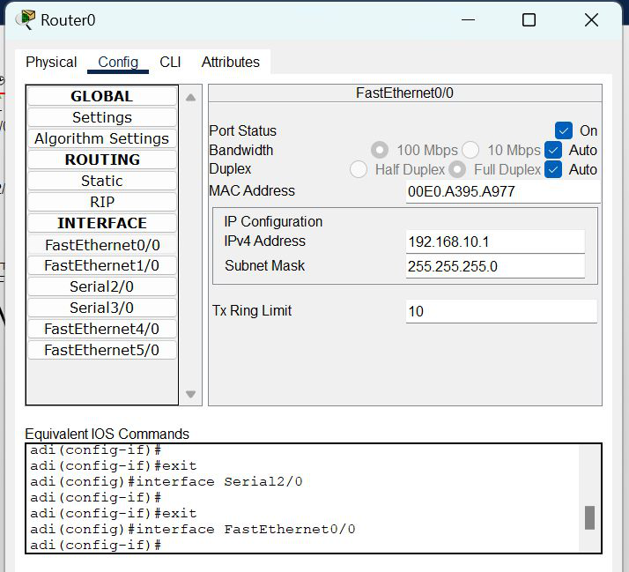
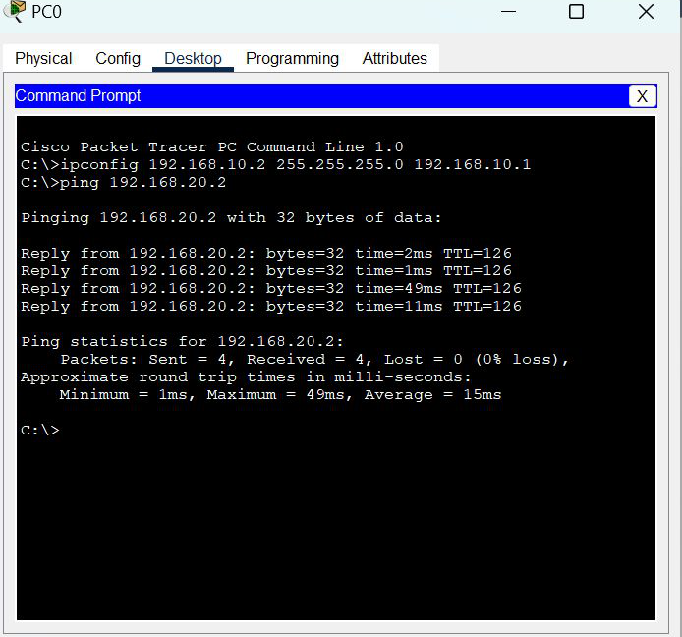

Observation & Learning
- RIP Updates: During the experiment, we observed that RIP routers exchanged routing information with each other. This exchange of information allowed the routers to learn about available paths to various network destinations.
- Routing Table: The routers maintained routing tables containing information about the network topology, including network addresses and associated metrics (hop counts).
- Path Selection: RIP selected paths based on hop counts, preferring paths with fewer hops to reach a destination network.
- Network Changes: When we introduced network changes by disconnecting and reconnecting cables, RIP routers updated their routing tables to adapt to the new topology.
Conclusion
In conclusion, the experiment demonstrated the basic operation of the Routing Information Protocol (RIP) in exchanging routing information among routers to establish paths from source to destination. RIP routers efficiently updated their routing tables in response to network changes, showcasing their adaptability in maintaining network connectivity.
Questions
- What type of ports are used for the connection between the routers?
Ethernet ports (typically Fast Ethernet or Gigabit Ethernet) are commonly used for connecting routers in a network.
- How does RIP ensure the path from source to destination?
RIP ensures the path from source to destination by exchanging routing information between routers and selecting the path with the fewest hops (shortest path) based on hop counts.
- What is the importance of the gateway address?
The gateway address (also known as the default gateway) is crucial in routing as it serves as the exit point for traffic leaving a local network. It enables devices within a network to access resources outside of that network, such as the internet, by forwarding traffic to the appropriate router for further routing.

